Distillery Web Map Development with Leaflet, Shiny, with R

Caleb Ellis

Geography 499, Senior Assignment

July 22, 2019

1. **Introduction**

The goal for any map is to show where a place is geographically in relation to other locations or landmarks. Maps can provide information about areas and locations as well. Just like any other tool, it has evolved rapidly as technology has developed over the past few decades. Today, multiple needs require and benefit from modern mapping and Geographic Information Systems (GIS). The advent of the internet has allowed new avenues for mapping techniques to develop. A commonly used form of GIS is web-based GIS (also known as web mapping, or web GIS) and has been utilized in an array of different services. The growth of technology and software allowed elements of web GIS to be fleshed out throughout the 1990s and into the 2000s (Godfrey and Stoddart 2018, 34).

From cave carvings to LiDAR, humans have developed various techniques for illustrating locations. At its core, mapping is a language interpreting and analyzing spatial data. Mapping can be used in a way where it can be implemented in many daily functions. Web mapping has been a pivotal technology for relaying spatial data and is crucial for many background processes for GIS professional and nonprofessional services. GIS has been implemented in many tools being used in apps and services. The average users of these apps use GIS in built-in GPSs on smartphones, Peer-2-Peer services like Uber and Grubhub, and real estate websites like Zillow. These types of applications are built off and use GIS to offer users convenient solutions for tasks. Application-based GIS might seem very minor when compared to other GIS technologies, but it is fully ingrained into daily life. The process of integrating web GIS has become easier over the years and has allowed many developers to take advantage of these tools. The need for GIS implementation is crucial for illustrating locations in a readable and elegant way.

The purpose of this project is to utilize web GIS for illustrating the locations of many bourbon distilleries while providing information about the distilleries. The data used for the map include where the distilleries have been established, identifiable clusters of distilleries, and links to individual website and addresses. Although there are several methods for showing this data, interactive web-based mapping would be an appropriate tool for the project goals.

1. **Background on topics**

2a. Modern web mapping, open source design, and ESRI

The state of technology is in a much different state compared to when Xerox’s PARC was released. Many tools for web GIS web application development are available through Free/Open Source Software (FOSS) community. An open source software offers a free alternative to proprietary software. Open source software is defined by four freedoms: 1. freedom to use the software for any purpose; 2. freedom to modify and study the software; freedom to redistribute the software; 4. freedom to create changes to the software and release the changed software to the public (Sillero and Tarroso 2010, 63-65). Caldeweyher, Zhang, and Pham (2006) explained why open source GIS and other software was needed in the OpenCIS project. The OpenCIS project aimed to produce a cost-efficient and open source software. “In today’s information age, where information means power, power is given to those that have the capabilities to collect, analyse, and publish information. GIS efficiently provides these capabilities for large amounts of spatial information.”

The goal of the OpenCIS project was to create an accessible and user-friendly development tool to process and analyze data. Over a decade later, design philosophies such as the one presented for the OpenCIS project are shared amongst many modules, software, operating systems, and languages used by professionals and hobbyists alike. Some examples are Jupyter, QGIS (once released under the name Quantum GIS), GRASS, SAGA, GeoDa, Leaflet, and Open JUMP GIS to name a few. Software packages and languages are designed (or have heavy use) for GIS development and follow the four freedoms of open source design.

In the world of GIS, ESRI is one of the major companies in the industry and provide a wide array of proprietary GIS products. Many of their numerous software packages and services appeal to professionals and educational programs on all levels. One product ESRI offers is ArcGIS Online (AGOL). As of 2019, ESRI has priced the GIS Professional advanced user license at $3,800 a year. The purchasing of the advanced user license allows administrative privileges, a full development tool set, sharing maps by publishing onto the web, collaboration between creators and other roles, and application development. ESRI offers a slew of mapping tools for development going beyond the key points previously mentioned.

There are options for what platform one can chose when building a GIS. It is important to understand the fundamentals of what is being built and GIS in general. Dave Peters (2008) writes in *Building a* *GIS: System Architecture Design Strategies for Managers*, “… [GIS] is not at heart a step-by-step process anymore. It is more like working on a puzzle. There are procedures within the process, such as those that must be followed during a project implementation, but first, as in a puzzle, a system must be understood as a whole before it can be properly put together” (Peters 2008). In today’s software and hardware landscape, many different software designs, programs, processes, and techniques can be applied to a GIS project to achieve similar results when done in a different manner. For instance, a map could be published as a deliverable on ArcGIS Online, but have data built and managed in development with open source tools like ArcPy, Jupyter, and Anaconda. Thanks to the abundance of GIS design tools and languages, spatial data and geographic topics can be illustrated in a dynamic and effective way.

2b. Bourbon as a Geographic topic

Some spirits and alcoholic beverages use geographic origin in advertising because many are linked to a specific region or country. Some spirits that use geographic origin include scotch from Scotland, sake from Japan, tequila from Mexico, and bourbon from Kentucky. Bourbon is one spirit that has many links to Kentucky (Veach 2013). The common misconception is all bourbon must be distilled in Kentucky, and it must be made from 51% corn mash and aged in virgin oak barrels. The United States Congress stated: “[Whereas] ‘Bourbon whiskey’ has achieved recognition and acceptance throughout the world as a distinctive product of the United States…”, (S. Res. 19, 1964).

Since bourbon can be made in any State in the United States, new distilleries have opened their door nationwide during the current whiskey boom. Production for established distilleries has grown substantially over the past decade in many states. Reports on why growth has occurred is due to modernization and the appeal of a premium product in both domestic and international markets. In 2016 the market saw a growth of 4.1% for spirits overall and a staggering 7.8% growth in 2015 with a revenue of 2.9 billion dollars (Chew 2016). Popular brands like Bulliet are opening and establishing an independent distillery location with plans of another distillery. Schreiner (2017) reported on the company selling over 725,000 cases in 2015, making it the fifth largest distillery in the United States. Kentucky has many distilleries that vary in size and production output.

Today some smaller, craft distilleries reside in Tennessee as well. Due to Tennessee being the southern neighbor of Kentucky and the history of people farming and distilling from the same types of land, it is hard to tell where the truth lies with bourbon’s origin. Some say it was created in Bourbon County, some say Elijah Craig was the father of it (Mitenbuler 2016). Others think that it came naturally from the people that farmed and distilled in the land between the Ohio River and the Mississippi River. Mash recipes and distilling techniques varied for each farm and family that produced moonshine and whiskey. What I known today is that bourbon took some form in the 19th century, but not at the level of standardization that we see today (Spoelman and Haskell 2013).

The booming business of bourbon is not just increasing sales but also creating a culture around distillery tourism and vacationing. Since Kentucky has the many large-scale bourbon distilleries and feature tours, shops, bars, and restaurants on their property. Tours are a great way for distilleries to make an extra income and states with breweries, vineyards, and distilleries benefit from the added attraction they bring to tourist. The key component of the tours is the experience brought about from the environment (Halladay 2012). A tool that could help those wanting to visit these distilleries for tours is a web map showing where these distilleries are while creating a way to easily access distilleries websites.

**3. Method**

3a. Data collection

The first step for most maps is to record the information that will be used in the map with the use of a database or a geodatabase (which is mainly an ESRI process). For the bourbon map, a database was created so information about distilleries could be stored within a .csv file. The file was created by using Excel. The file created in Excel will act as the home to where all the data can be stored. In the language R, which will be used, the set of data is often referred to as the data frame. Hypothetically, everything made in the Excel file could have been made solely in R. Without the creation of the data frame, the points that will be needed for the bourbon map cannot be made.

The data is the most crucial part of the data collection process. It should be organized and readable regardless of the program in which it was built. The data should be somewhat universal for usage in software or tools. It is regarded as a good practice to plan and understand what kinds of data is being used and how it is being used in a GIS project. The quality of the data used will affect the features built with the data. If data is left in a disorganized state, then the future curation of the map or database could be difficult. Web maps are often managed over time and worked in collaboration and should be indexed properly. Features and new data are added over long periods of time and the effort in organization with initial data creation could help in future development (Tomlinson 2007). An organization tool like a table should be constructed to know what data should be included.

|  |  |
| --- | --- |
| **Brand** | (String) Name of the distilleries/ brand name. |
| **State** | (String) The state where the distillery home to. |
| **City** | (String) City where the distillery in located. |
| **Street Address** | (String) Street Address of the distillery. |
| **Latitude (lat)** | (Double) The latitudinal coordinate of the distillery. |
| **Longitude (long)** | (Double) The longitudinal coordinate of the distillery. |
| **Year** | (Date/Year) The year that the distillery has operated since prohibition. |
| **Website** | (HTML) A hyperlink to take users to the distillery’s website. |

Table 1. The table designed to organize the types of data used for the bourbon directory.

*Source*: Caleb Ellis*, 2019*

Since the data needed has not been stored in an open database, it was obtained manually from various online sources. The brands were found and recorded by searching online stores, other maps of distilleries, Author’s personal knowledge of the brands, and from the brands being featured or mentioned by users on the bourbon subreddit (r/bourbon). After collecting names of 35 distilleries, the process of searching online for addresses and website URLs began. This process entailed visiting every website to confirm if it was the official site of the distilleries. Once the weblinks were proven to be correct, some data was able to be collected directly from the sites. Some distilleries published their addresses and founding years, while others did not. The purpose of the addresses is to tell the user where a distillery is and to help find the data for the coordinates. Even though the points can be drawn without the addresses, it is important to the user because it can tell them exactly where the location is and can be easily back traced with a quick Google search or GPS input.

Deciding which data is relevant to show the user is important, and in this particular case, outright displaying data like longitude and latitude would be unnecessary. Longitude and latitude were required to be recorded despite never being shown to the user. The purpose of collecting coordinates was for the rendering of the points. Points that are created from coordinates is a far more direct and simpler method than using addresses to place points. The process of collecting coordinates from addresses was done via: <https://www.latlong.net/lat-long-dms.html>, which simply involved entering the address, city, state, and zip code. The process of coordinate collection did involve some manual work, which was simple and the data appeared to be quite accurate.

3b. Design Procedure and Process

There are several approaches to working with data for a web map after the data has been collected and organized properly. Different methods require different procedures within the planning process. The method for creating a web map with the distillery data will fist make use of an open source library originally designed for Java, and later ported R. The library used is called Leaflet. The R variant of Leaflet will be used for the map’s creation and was created by RStudio, Incorporated. The second part of this method requires the use of a package and service called Shiny. Shiny allows R scripts to be illustrated and hosted online through an .io web extension. An important step to programming is planning, knowing which libraries will need to be used beforehand will help in organizing the workflow of writing a script or program. Along with knowing which libraries will be used, it is also a mindful habit to dedicate a project folder as a directory that the script will use to call and write data.

The first step in creating a map using leaflet is to load in the data. Loading in a .csv file is a simple process in R because the *read.csv()* function reads and loads the data in. The *read.csv()* function translates the data and formats it automatically as a workable data frame. Since points will be needed, a set of custom point graphics were created. Although Leaflet provides options for point icons, it has also includes the use of custom point graphics from file types such as .png files. The icons used were made in an open source photo editor called GIMP. Icons such as the one made for this map can be created in any photo editor with the ability to export to an accepted file type. The makeIcon() function takes the .png and configures it into data that can be read as an icon in Leaflet.

The use of magrittr pipe operator (*%>%)* is recommend by RStudio and many R programmers alike. It is used to manage arguments in a chain by making the code intuitive for reading and writing. The benefits from using pipe operators are data being structured from left to right, functions are not nested, and additions to the code can be easily done (Bache 2014). Structuring the code with the use of pipes allows map creation in Leaflet to be better managed over time. The hypothetical “pipeline” created allows for ease in modifications to the app to be done in a relatively efficient manner.

Information for what the script will do with the data will be defined in the server argument. The distillery data will be defined in the *leatlet()* function, which will be followed by defining what will be used as a base map. The *addProviderTiles()* function calls on a hosted map provider to add a map layer to the Leaflet map. The map tiles used from a provider will be the ESRI World Street Map. The same layer will be duplicated in a displayed mini map. The mini map allows an additional map to be displayed with a different scale and is implemented so it can provide better navigation.

The next function used was the *addMarkers()* function, which allows the parameters of the makers elements to be set and defined. The first parameter to be defined was the data for long (longitude) and lat (latitude) in the data frame. The data created and defined as a *marker* will be defined as a group called “marker”. Groupings for Leaflet are similar to features in an ESRI-like environment. The *markerClusterOptions()* method toggles on the ability for the map to render boundaries of clusters. The two factors for wanting to cluster markers in Leaflet are the reduced rendering time because the clustering allows “chunking” of the data and it can help defining local regions of distilleries.

The final function used for the map is assigning the popup variable in *renderLeaflet()* with *paste()*. The data assigned into *paste()* was distillery, address, year of production, and website. The data was called from the data frame as *distilleries$Brand* for distillery, *distilleries$Address*, *distilleries$City, distilleries$State* for address, *distilleries$year* for year, and website as *distilleries$Website*. *Paste()* is used to format and organize the data as it is called upon to be displayed for each respected distillery. The ability to locally render a map should be satisfied after these functions have been properly programmed, this script is saved as server.R.

server.R

#Import Libraries

library(leaflet)

library(shiny)

library(rsconnect)

setwd('C:/Users/Caleb/Documents/R_Practice')

#Load distillery .csv

distilleries <-read.csv('directory.csv', stringsAsFactors = FALSE, header = TRUE)

#Load PNG

iconB<- 'Icon.png'

#Set properties of Icons.png

dis_icon<-makeIcon(

iconUrl= (iconB),

iconWidth = 60, iconHeight = 75,

iconAnchorX = 0, iconAnchorY = 0

)

server <- function(input, output,session) {

#Render the markers and map

output$map <- renderLeaflet({

l<- leaflet(data = distilleries)%>%

addTiles() %>%

#addProviderTiles(providers$Stamen.Toner) %>%

addProviderTiles(providers$Esri.WorldStreetMap) %>%

addMiniMap(toggleDisplay = T)%>%

addMarkers(~long, ~lat,

group = "marker",

#Makes Clusters

clusterOptions = markerClusterOptions(removeOutsideVisibleBounds = F),

icon = dis_icon,

#Properties for the popup window

popup = paste("Distillery: ",distilleries$Brand,"<br>",

"Address:", distilleries$Address,",",distilleries$City, distilleries$State,"<br>",

"Year of Production ", distilleries$year,"<br>",

"Website: ", distilleries$Website))

})

}

The next script required for the map is ui.R. ui.R exists to define the elements for the user interface (UI) and is naturally shorter. For the purposes of the project, the UI was designed to be simple and will only display a few elements. The elements were displayed was the title and information referring to the project name and author. The map needed to be downscaled slightly in the UI so it could fit within the UI while also fitting on a single screen. If the height in the *leafletOutput()* stayed at the default 100% size, then the mini map would be cut off. The size of the height changed to 90%, allowing all elements of the map to be displayed on a standard 16:9 widescreen display.

ui.R

#The UI properties

ui <- bootstrapPage(

#Names and Labels for top of UI

fluidRow(

column(8,

h2("Bourbon Map"),

h3("Caleb Ellis Senior Assignment 2019 ", style = "color:DarkRed"))),

tags$style(type = "text/css", "html, body {width:100%;height:100%}"),

leafletOutput("map", width = "100%", height = "90%"),

absolutePanel(top = 10, right = 10,

tags$h3("Click on a distillery to learn more.")

)

)

After the two required parts of the Leaflet map have been created, the process of uploading the map to a web service is required. A common implementation of Leaflet maps is through imbedding the map into webpages. For the purposes of this project, the map will instead be hosted on its own page through Shiny.io. Shiny requires an account to host and is free to use for personal uses. Hosting on Shiny for business purposes may not be optimal and many website hosting services allow for imbedding. Some legality issues might arise while using OpenStreetMap, therefore, it is better to fully read the user agreements and any legal documentation of software being used. Since the bourbon map is being created for an educational/ personal use, the map can be freely hosted for demonstration purposes. Publishing though RStudio requires Shiny to configure a few files by reading the server.R and ui.R scripts. After the publishing process is done, the map will be live and can be managed and updated through the shiny.io account connected to the map.

1. **Conclusion**

Overall, creating an interactive web map has become an easier task, more so than it has ever been. Online resources have lowered the barrier of entry for many tools that would otherwise be daunting to teach oneself. Since the general landscape of open source tools seem to be somewhat in its infancy, it appears to have room to grow (Sack, et al. 2018). It is natural for GIS technology to grow and for techniques to develop. FOSS-based web mapping can be a cost effective and customizable alternative to proprietary software.

The flexibility and array of already established tools and functions built into leaflet create a dynamic environment. The FOSS approach for mapmakers allows the potential for very complex and detailed maps without purchasing proprietary software. The bourbon map, for example, could be expanded upon and be developed into a mobile app. A GPS function of smart phones could also be implemented so users could be routed to the distilleries. Another development route for the map could be more interactive features. For example, videos could be imbedded into the app and show the process of how distilling works. Another set of popups could be included, giving information about cities and about their historical legacy with bourbon.

The more map makers use tools, such as shiny and leaflet, the more web mapping communities can expand their knowledgebase (Sack, et al. 2018). Each developer of a map will naturally use a variety of tool, thus creating a different workflow. Interactive maps can be used in all fields of geography whether it be cultural, political, or physical. Although, we are in the early stages of this type of technology, it acts as a strong platform for future GIS platforms. Tools such as leaflet and ArcGIS Online grant geographers the ability to customize and share maps in a way that would have been impossible before.

1. **Appendix**

The bourbon map can be viewed at: <https://calebellisprojects.shinyapps.io/r_practice/>

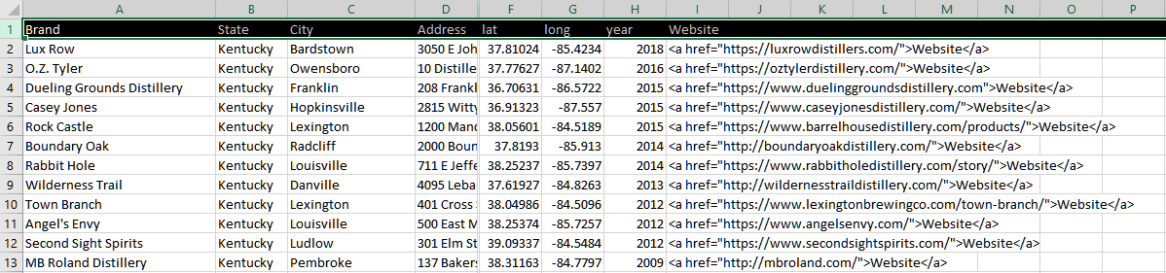Figure 1. A screenshot of the csv file used. Notice the types of data recorded.

*Source:* Caleb Ellis, 2019

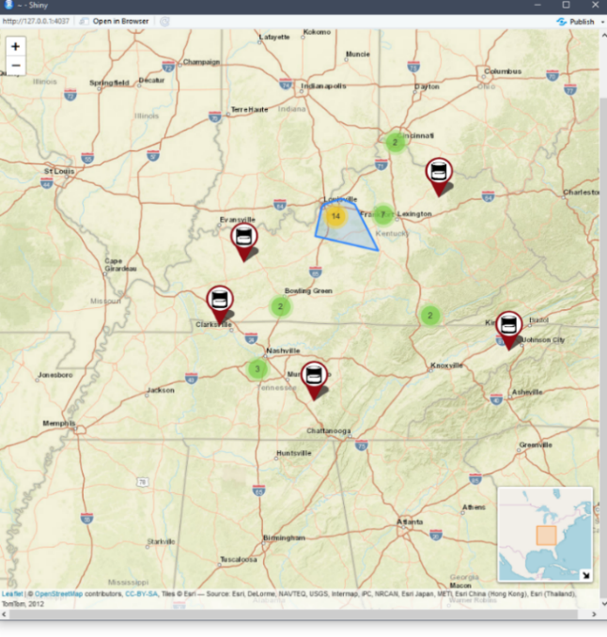

Figure 3. The clustering feature in action. Notice the large cluster that has a boarder generated around it.

*Source:* Caleb Ellis, 2019

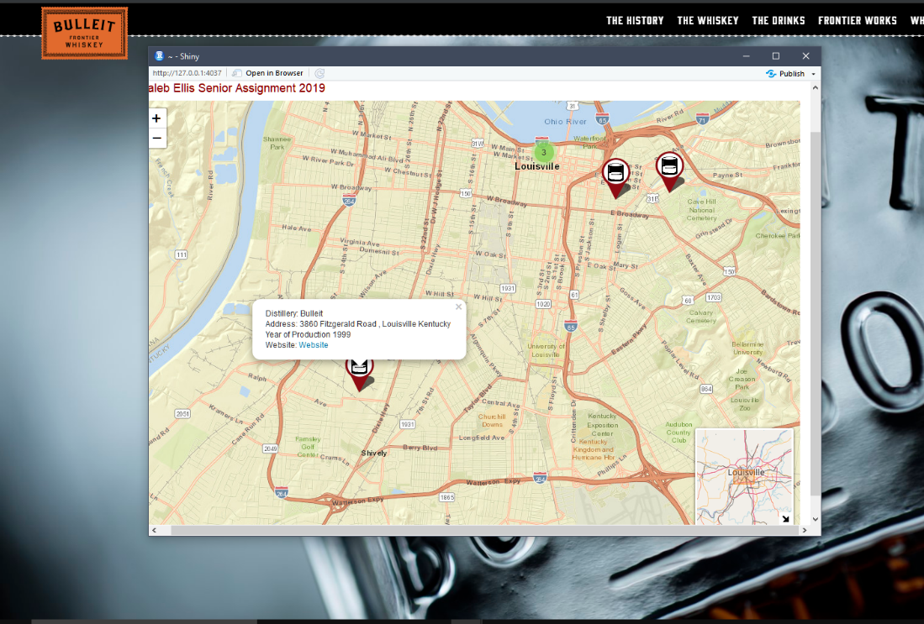

Figure 3. An example of the web map utilizing pop ups and directing users to the distiller’s website.

*Source:* Caleb Ellis, 2019

# Works Cited

Andrienko, Gennady, Sara Irina Fabrik, Amy L. Griffin, Jason Dykes, and Jochen Schiewe. 2012. "Geoviz: Interactive Maps that Help People Think." *International Journal of Geographical Information Science* 10 (28). doi:10.1080/13658816.20.

Bache, Stefan Milton. 2014. *Magrittr Package Introduction and Basics.* November. https://cran.r-project.org/web/packages/magrittr/vignettes/magrittr.html.

Caldeweyer, Daniel, Jinglan Zhang, and Binh Pham. 2006. "OpenCIS: Open Source GIS-based web community information system." *International Journal of Geographical Information Science* 20 (8): 885-898.

Chew, Johnathan. 2016. "Bourbon and Whiskey Sales are Soaring Around the World." *Fortune.com.* Febuary 3. Accessed February 11, 2019. http://fortune.com/2016/02/03/whiskeys-bourbon-spirits-sales/14.937719.

Farkas, Gabor. 2017. "Applicability of open-source web mapping libraries for building massive Web GIS clients." *Journal of Geographical Systems* (19): 273-295. doi:10.1007/s10109-017-0248-z.

Godfrey, Bruce, and Rick Stoddart. 2018. "Managing In-Library Use Data: Putting a Web Geographic Information Systems Platform through Its Paces." *Information Technology and Libraries* 37 (2): 34-49.

Halladay, Jessie. 2012. "Tourists Drawn to Distilleries, Breweries." *USA Today*, March 16: 08a.

Hu, Shunfu, and Ting Dai. 2013. "Online Map Application Development Using Google Maps API, SQL Database, and ASP.NET." *International Journal of Information and Communication Technology Research* 3 (3): 102-10.

Mitenbuler, Reid. 2016. *Bourbon Empire.* New York: Penguin USA.

Peters, Dave. 2008. *Building a GIS: System Archeitecture Design Strategies for Managers.* Redlands, California: ESRI Press.

Pitock, Todd. 2014. "On the Whiskey Trail." *The Saturday Evening Post*, April 17. www.saturdayeveningpost.com/2014/04/on-the-whiskey-trail/.

Roth, Robert E, and et al. 2015. "A Process for Keeping Pace with Evolving Web Mapping Technologies." *Cartographic Perspectives* 78: 25-52. doi:10.14714/cp78.1273.

RStudio, Inc. 2016. *Leaflet for R.* https://rstudio.github.io/leaflet/map_widget.html.

Sack, Carl M, Richard G. Donohue, Timothy R. Wallace, Carl M. Sack, and Tanya M. A. Buckingham. 2018. "The Status of Web Mapping in North American Higher Education." *Cartographic Perspectives* (89): 25-43. doi:10.14714/cp89.1429.

Schreiner, Bruce. 2017. "Bourbon Flowing: Bulleit Brand Opens Its First Distillery." *Associated Press*, March 14.

Sillero, Neftalí, and Pedro Tarroso. 2010. "Free GIS for herpetologists: free data sources on Internet and comparison analysis of proprietary and free/open source software." *Acta Herpetologica* 5 (1): 63-85.

Spoelman, Colin, and David Haskell. 2013. *The Kings County Distillery Guide to Urban Moonshining.* New York: Abrams.

Tomlinson, Roger. 2007. *Thinking About GIS: Geographic Information System Planning for Managers.* Redlands, California: ESRI Press.

U.S. House of Congress. 1964. "Bourbon Whiskey Designated as Distinctive Product of the U.S." *Res. 19.* May 4.

Veach, Michael R. 2013. *Kentucky Bourbon Whiskey: An American Heritage.* Lexington: University Press of Kentucky.